**ACHARAYA INSTITUTE OF TECHNOLOGY**

**BENGALURU 560107**

**CLOUD COMPUTING MODULE2:**

**VIRTUALIZATION:**

Virtualization in Cloud Computing refers to the technology that enables the creation of virtual (rather than physical) versions of resources such as servers, storage devices, and networks. It plays a crucial role in cloud computing by allowing efficient resource management and scalability. Here's a breakdown of its key concepts and components:

1. What is Virtualization?

Virtualization is the process of creating a virtual version of something, such as hardware, storage, or network resources. It allows multiple operating systems and applications to run on a single physical machine by partitioning it into virtual environments.

Here is diagram for virtualization

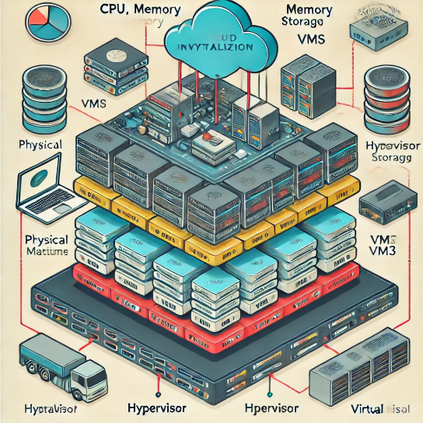

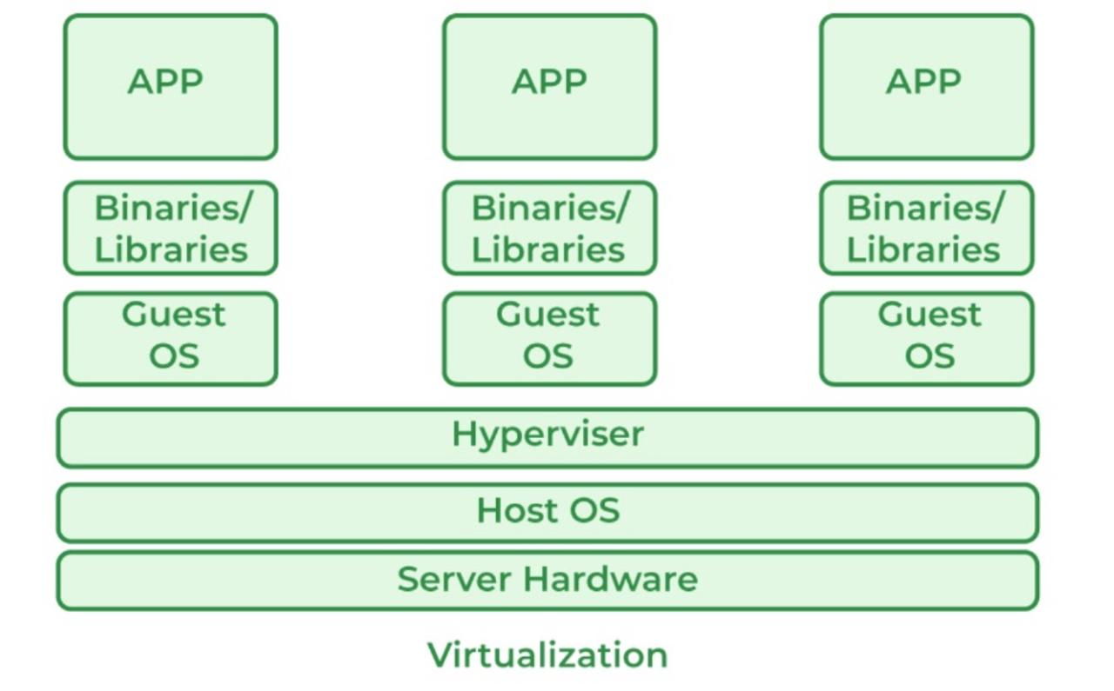

2. Types of Virtualization in Cloud Computing

- Server Virtualization: This allows multiple virtual servers to run on a single physical server, maximizing resource utilization. Virtual machines (VMs) are created, each running its own OS.

- Storage Virtualization: Combines physical storage from multiple devices into a single, centralized storage unit, which can be accessed by multiple users or VMs.

- Network Virtualization: Abstracts physical network resources to allow multiple virtual networks to run on a single physical network infrastructure.

- Desktop Virtualization: Enables users to access a virtual desktop environment from any device, hosted on a remote server.

3. How Virtualization Works in Cloud Computing

Virtualization in the cloud is primarily achieved through hypervisors , which are software, firmware, or hardware that create and manage virtual machines. Hypervisors enable multiple operating systems to share a single hardware host, providing an abstraction layer between the physical hardware and the operating systems.

There are two types of hypervisors:

- Type 1 (Bare-metal Hypervisors): Run directly on the hardware and are more efficient as they don't require an underlying OS (e.g., VMware ESXi, Microsoft Hyper-V, Xen).

- Type 2 (Hosted Hypervisors): Run on an existing operating system and are lessefficient because they require the resources of the OS (e.g., Oracle VirtualBox, VMware Workstation).

Here is diagram for hypervisor type1 and type2

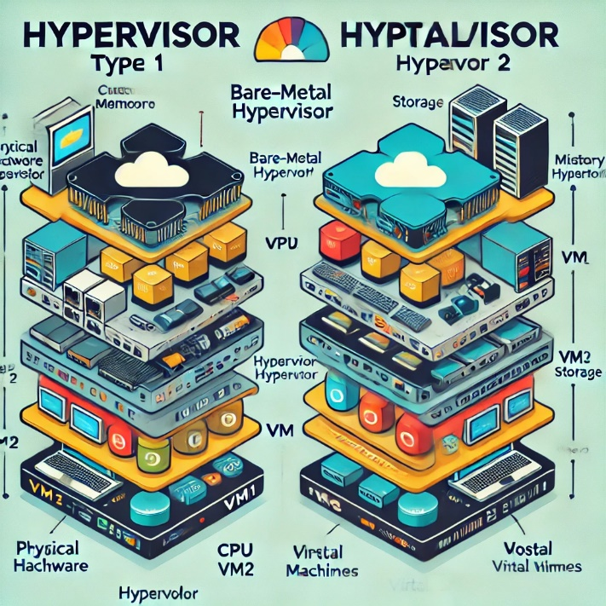

4. Benefits of Virtualization in Cloud Computing

- Cost Efficiency: Reduces the need for physical hardware by consolidating workloads onto fewer machines.

- Scalability: Resources can be allocated dynamically, allowing businesses to scale up or down based on demand.

- Resource Optimization: Virtual machines ensure better use of computing resources, leading to higher efficiency.

- Flexibility: Enables the quick provisioning of virtual machines, supporting dynamic workloads and diverse applications.

- Disaster Recovery: Virtual machines can easily be backed up, cloned, or migrated to different physical hosts, enhancing disaster recovery capabilities.

5. Role in Cloud Service Models

- Infrastructure as a Service (IaaS): Virtualization is fundamental to IaaS, where cloud providers offer virtualized computing resources over the internet. Users can rent virtual servers, storage, and networking services (e.g., AWS EC2, Google Compute Engine).

- Platform as a Service (PaaS): In PaaS, virtualization helps abstract the underlying infrastructure, allowing developers to focus on building applications without worrying about managing servers.

- Software as a Service (SaaS): Virtualization allows SaaS providers to efficiently deliver software applications over the cloud without managing the underlying infrastructure.

6. Popular Virtualization Technologies

- VMware: A leader in virtualization technology, VMware provides solutions for server, storage, and network virtualization.

- KVM (Kernel-based Virtual Machine): An open-source virtualization technology integrated into the Linux kernel.

- Microsoft Hyper-V: A hypervisor-based virtualization platform used to create and manage virtual machines on Windows systems.

- Xen: An open-source hypervisor that powers many cloud service providers, including AWS.

7. Challenges of Virtualization in Cloud Computing

- Security Risks: Virtual machines can introduce new attack vectors if not properly secured.

- Resource Contention: Overloading a physical machine with too many VMs can lead to performance issues.

- Complexity: Managing a large number of virtualized resources can become complex without the proper tools.

8. Conclusion

Virtualization is at the core of cloud computing, enabling cloud providers to offer scalable, flexible, and efficient services. By abstracting physical resources, virtualization allows multiple users and applications to share computing resources seamlessly, making cloud computing more cost-effective and reliable.

**CHARACTERISTICS OF VIRTUALIZED ENVIRONMENT**:

A virtualized environment refers to an IT setup where virtual instances (e.g., virtual machines, virtual networks) run on physical hardware, often using a hypervisor to abstract the underlying resources. Below are the key characteristics of a virtualized environment :

1. Resource Abstraction- Decoupling from Physical Hardware : Virtual machines (VMs) are independent of the underlying hardware, which allows the system to treat hardware resources like CPU, memory, and storage as pools that can be allocated dynamically.

- Hardware Independence: VMs can run on different hardware platforms without being tied to specific hardware configurations.

2.Isolation -Separate Environments: Each virtual machine operates in an isolated environment, meaning that failures or changes in one VM do not affect others running on the same physical hardware.

- Security: Isolation also enhances security since one VM cannot directly access another VM's data without appropriate network permissions.

3.Dynamic Resource Allocation - Elasticity: Resources such as CPU, RAM, and storage can be allocated dynamically based on demand. This allows for efficient scaling, ensuring that workloads get the resources they need when needed.

- Load Balancing: A virtualized environment can automatically balance the load across multiple physical servers, preventing any one machine from becoming overburdened.

4.Efficiency and Optimization - Higher Resource Utilization: Multiple VMs share the same physical resources, ensuring that hardware utilization is maximized.

-Reduced Hardware Costs: By consolidating several workloads on fewer physical machines, virtualization reduces the number of physical servers required, leading to cost savings.

5.Portability and Flexibility - VM Migration: Virtual machines can be easily moved from one physical host to another with minimal downtime, enabling high availability and load management.

- Cross-Platform Compatibility : Virtualized environments allow applications and operating systems to run across different hardware platforms without requiring specific configurations.

6. Snapshotting and Cloning - Snapshots: Virtual environments support creating snapshots of a VM’s state at any point in time, allowing administrators to roll back to a previous state if needed.

- Cloning: Entire virtual machines can be duplicated, which is useful for backups or creating multiple instances of the same configuration.

7.High Availability and Disaster Recovery -Failover Mechanisms: In case of hardware failures, virtual machines can be quickly restarted or migrated to another physical server, minimizing downtime.

- Backup and Recovery: Virtual machines are easier to back up, and recovery processes are faster due to the portability of virtual environments.

8.Security and Control - Hypervisor Security : Hypervisors manage and enforce isolation between virtual machines, offering control over the security of the virtualized environment.

- Access Control: Administrators can define user permissions and access levels to virtualized resources, ensuring that only authorized personnel can interact with certain VMs or applications.

9. Automation and Orchestration - Automation Tools: Virtualized environments often come with tools for automating tasks such as VM provisioning, monitoring, and scaling.

- Orchestration: Many virtual environments integrate with orchestration tools like Kubernetes, allowing automated deployment and management of containers and VMs. 10.Cost-Effective Operations - Reduced Physical Space and Power: Consolidation of multiple virtual servers onto fewer physical machines reduces data center space, power, and cooling requirements.

Pay-as-You-Go Model: In cloud-based virtual environments, resources can be consumed on a pay-as-you-go basis, optimizing costs according to actual usage.

11.Multi-Tenancy - Shared Infrastructure: In cloud environments, virtualization allows multiple tenants (users or organizations) to share the same physical resources while keeping their environments logically separated.

12. Centralized Management - Unified Control Panel: Virtualized environments are often managed through a central interface that allows administrators to monitor and manage multiple virtual machines, storage units, and network resources from a single platform.

- Remote Management: Resources in virtualized environments can often be managed remotely, facilitating system administration and troubleshooting from anywhere.

In summary, virtualization transforms physical resources into more flexible, scalable, and manageable virtual entities, providing benefits like isolation, efficient resource utilization, and enhanced disaster recovery capabilities.

TAXONOMY OF VIRTUALIZATION TECHNIQUES:

**Virtualization** is technology that you can use to create virtual representations of servers, storage, networks, and other physical machines. Virtual software mimics the functions of physical hardware to run multiple virtual machines simultaneously on a single physical machine.

Virtualization is mainly used to emulate the execution environment, storage, and networks.

The execution environment is classified into two:

1.**Process-level**— implemented on top of an existing operating system.

**2. System-level**— implemented directly on hardware and does not or minimum requirement of the existing operating system.

The Host Machine is the term used to refer to the machine where the virtual machine will be created, while the virtual machine itself is called the Guest Machine.The advantages of virtualization include flexible and efficient resource allocation, improved productivity in development, reduced IT infrastructure costs, remote access and quick scalability, high availability and disaster recovery, pay-per-use of IT infrastructure on demand, and the ability to run multiple operating systems.

**Virtualization Categories:**

1.Application Virtualization.  
2. Network Virtualization.  
3. Desktop Virtualization.  
4.Storage Virtualization.  
5.Server Virtualization.  
6.Data virtualization.

**Virtualization is mainly used to emulate:**

**1] Execution Environments:** To provide support for the execution of the programs example. OS, and Application.

**Process Level:** Implemented on top of an existing OS that has full control of the hardware

**System Level:** Implemented directly on Hardware and do not require support from existing OS.

**2] Storage:** Storage virtualization is a system administration practice that allows decoupling the physical organization of the hardware from its logical representation.

**3] Networks:** Network virtualization combines hardware appliances and specific software for the creation and management of a virtual network.

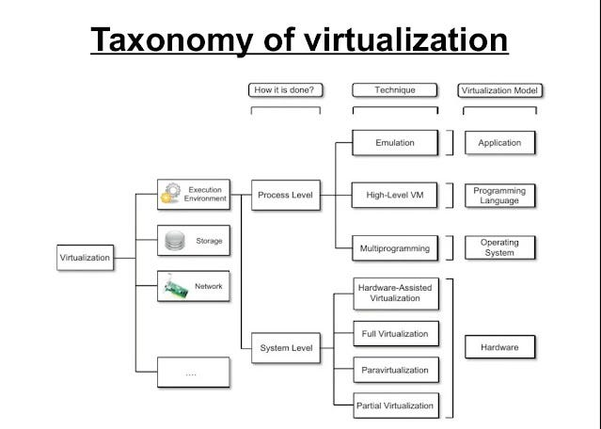

**Pros of Virtualization**

* **Utilization of Hardware Efficiently:**With the help of Virtualization Hardware is Efficiently used by user as well as Cloud Service Provider. In this the need of Physical Hardware System for the User is decreases and this results in less costly.In Service Provider point of View, they will utilize the Hardware using Hardware Virtualization which decrease the Hardware requirement from Vendor side.
* **High Availability:**One of the main benefit of Virtualization is that it provides advance features which allow virtual instances to be available all the times.
* **Disaster Recovery is efficient and easy:**With the help of virtualization Data Recovery, Backup, Duplication becomes very easy. In traditional method , if somehow due to some disaster if Server system Damaged then the surety of Data Recovery is very less. But with the tools of Virtualization real time data backup recovery and mirroring become easy task and provide surety of zero percent data loss.
* **Virtualization saves Energy:**Virtualization will help to save Energy because while moving from physical Servers to Virtual Server’s, the number of Server’s decreases due to this monthly power and cooling cost decreases which will Save Money as well.
* **Quick and Easy Set up:**In traditional methods Setting up physical system and servers are very time-consuming. Firstly Purchase them in bulk after that wait for shipment. When Shipment is done then wait for Setting up and after that again spend time in installing required software etc. Which will consume very time. But with the help of virtualization the entire process is done in very less time which results in productive setup.
* **Cloud Migration becomes easy:**Most of the companies those who already have spent a lot in the server have a doubt of Shifting to[Cloud.](https://www.geeksforgeeks.org/cloud-based-services/)But it is more cost-effective to shift to cloud services because all the data that is present in their server’s can be easily migrated into the cloud server and save something from maintenance charge, power consumption, cooling cost, cost to Server Maintenance Engineer etc.
* **Resource Optimization**: Virtualization allows efficient utilization of physical hardware by running multiple virtual machines (VMs) on a single physical server. This consolidation leads to cost savings in terms of hardware, power, cooling, and space

**Cons of Virtualization**

* **High Initial Investment**: While virtualization reduces costs in the long run, the initial setup costs for storage and servers can be higher than a traditional setup.
* **Complexity**: Managing virtualized environments can be complex, especially as the number of VMs increases.
* **Security Risks**: Virtualization introduces additional layers, which may pose security risks if not properly configured and monitored.
* **Learning New Infrastructure:**As Organization shifted from Servers to Cloud. They required skilled staff who can work with cloud easily. Either they hire new IT staff with relevant skill or provide training on that skill which increase the cost of company.
* **Data can be at Risk:**Working on virtual instances on shared resources means that our data is hosted on third party resource which put’s our data in vulnerable condition. Any hacker can attack on our data or try to perform unauthorized access. Without Security solution our data is in threaten situation**.**